Game name | Category indoor/outdoor | Other
Game slip ‘n’ slide | Outdoor | Water activity/ Slime mat
Equipment | Large tarpaulin  Lilo  Slime made with Lux flakes  10 fizzy drinks bottles part filled with water  Sun glasses/ eye protection? | 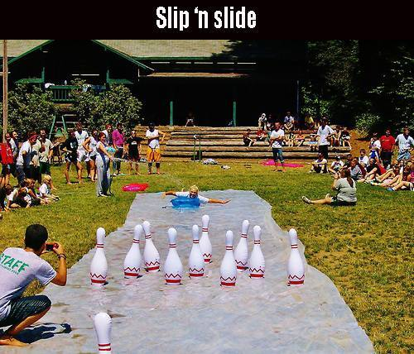
Rules | Each team member pushes themselves off and launches onto the lilo/ airbed  Once moving no further propulsion is allowed.  Arms must be kept at the sides of the body  Arms may not be used to knock over skittles  Points are awarded for the number of skittles knocked over | Extension  Skittles are colour coded and have different points values  Best of three and average the points  First team to score a total of 50 points or do it as a count back.  Timed activity e.g. 5 minutes total
Safety | Participants should not be wearing lose clothing  Participants to wear eye protection  Mat to be placed on flat or gently sloping ground NOT the steep bank  Mat should be well slimed to reduce friction  Water to wash eyes out should be available should participants get slime in eyes.  Spectators and fellow team members must not go onto the slide whilst someone is sliding  Care must be taken when replacing the skittles as risk of falling

